KÉPZÉSI FELHÍVÁS

Capacity Building Youth Training on Diversity and Youth Empowerment

Youth 4 Diversity

2007. július 23 – augusztus 2.
Lengyelország

A Future Factory és a Világbank a Silesian Center for Equal Opportunities, a Szlovák Ifjúsági Tanács, a TakingITGlobal és a Mobilitás Országos Ifjúsági Szolgálat szakmai együttműködésében angol nyelvű képzést szervez 18-24 év közötti fiatalok részére a tolerancia és az emberi jogok témakörében.

A képzésen Magyarországot 5 fiatal képviselheti, akik:
- 18-24 évesek
- jól beszélnek angolul
- helyi közösségükben aktívak
- mind csapatban, mind egyénileg jól tudnak dolgozni
- jó íráskészséggel rendelkeznek
- kreatívak, pro-aktívak és megbízhatók

A képzésre történő jelentkezés feltétele az alábbi angol nyelvű program megismerése és az űrlap angol nyelven történő kitöltése.
A jelentkezések beérkezésének határideje: 2007. június 8. 12.00 óra
Jelentkezni lehet faxon (06-1/438-1055) vagy e-mailen (marton.balazs@mobilitas.hu).
A beérkezett jelentkezések közül a Mobilitás Országos Ifjúsági Szolgálat, valamint a Világbank szakembereiből álló stáb választ ki öt főt, akiket június 11-ig értesítünk a döntésről és a további tudnivalókról.

További információ:
Foglalkoztatási és Szociális Hivatal – Mobilitás Országos Ifjúsági Szolgálat
Igazgatóság

Márton Balázs
Tel.: 06-1/438-1056
e-mail: marton.balazs@mobilitas.hu



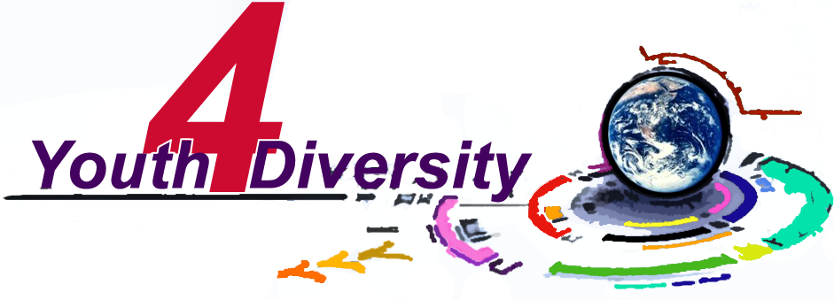

Capacity Building Youth Training on Diversity and Youth Empowerment

Poland, July 23.07-02.08 2007

A p p l i c a t i o n F o r m

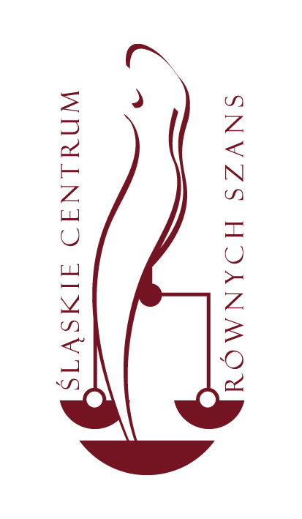




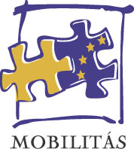
The World Bank

Overview:

Taking place in July 2007 the Capacity Building Youth Training on Diversity and Youth Empowerment “Youth 4 Diversity” is organized by Factory of Future and the World Bank in partnership with Silesian Center for Equal Opportunities, Youth Council of Slovakia, Mobilitas and TakingITGlobal at a crucial time characterised by the growing awareness from European policy makers that youth social inclusion, empowerment and tolerance have become burning issues urgently requiring resolved and ambitious policies at all levels.

The project aims to combine two major issues:
- prevent discrimination and exclusion trough promotion of diversity
- empower youth as agents of tolerance and mutual understanding and increase their capacity to be leaders in their local communities

The above will be achieved by creating a publication for youth on:
  - diversity and human rights - prepared by youth, trained on anti-discrimination efforts/actions.
  - practical aspects of anti-discrimination projects preparation and implementation, such as fundraising, public relations, team building and other aspects of project management.

The selected youth will receive materials with detailed project description two weeks before the first training in order to give the participants the time to develop their own ideas, from which the whole initiative could benefit.
- Initial trainings will follow the VC and will be organized separately in each country and provide local participants with knowledge on the discrimination, intolerance or violation of human rights in a particular country with a general overview of the region. They will take place in participants’ countries just before the main training in Poland.
- Second round of trainings, organized in Poland for all participants, will consist of three parts:
- project management
- general mechanisms of discrimination, presentation of activities, projects fighting discrimination and intolerance (e.g. how to organize an antidiscrimination workshop) and promoting diversity
- journalism, writing skills

Participants will receive a unique training which contains description of an obstacle (namely, discrimination) that youth is dealing with, together with a tool to overcome it. The publication they will create during the last three days of workshop will be based on the workshops they have participated in.
Additionally, there will be a network of young people created, able to act locally and communicate globally.

Technical Information:

- Number of participants: The Capacity Building Youth Training on Diversity and Youth Empowerment “Youth 4 Diversity” will gather around 10 participants coming from Poland, 5 from Hungary and 5 from Slovakia. Relevant guests from civil society organizations will be invited to contribute to this training.

- Applications: Only in written, with the enclosed participation form, to be sent to Mobilitás Országos Ifjúsági Szolgálat to the attention of MÁRTON Balázs: either by fax at +36-1 438-1056 or by email at marton.balazs@mobilitas.hu. The deadline for sending applications is until Friday, June 8th 2007 12:00 CET.

- Travel: Travel will be provided and covered by the Factory of Future, including flights and transportation to and from the airport and to and from training events.

- Final programme with exact time and venue will be sent to participants before the meeting. Please, reserve also one day before and after the training in case of changes in training agenda.

- Working language: English

- Profile of participants - Selection Requirements:

  - Being between 18 and 24 years old
  - Speaking fluent English
  - Being active in local community
  - Being able to work in team and as an independent worker
  - Having good writing skills
  - Being creative, pro-active and reliable

Type or CAPITAL LETTERS please!

Personal Information:

Name: _____________________________ Age /Date of birth: __________________

Gender: ____________________________ Nationality: ________________________

Address:

Street: _____________________________ Zip code: __________________________

City: _______________________________ Country: ___________________________

Email: ______________________________

Telephone: __________________________ Mobile: ____________________________

E-mail: _____________________________

I do understand, speak and write in English:

YES [ ] NO [ ]

Any special requirements (eg. disability or dietary): ___________________________________

____________________________________________________________________________

I hereby represent to the Factory of Future, that I have adequate medical and hospital insurance in case of an injury or illness. The name of my said insurance company, which will cover my on this trip, is __________________________, and my Policy Number is_____________________.

I request that in the event of any medical or other emergency involving myself during the project activities that:
Mr/Ms _____________________________, at phone number (_____) ____-________________ is contacted, that person will have authority to speak for me with respect to the emergency needs.

Motivation and Qualifications:

Please complete the following (be very brief):

1. What is your experience of being active in civil society?
(Please, include names of organizations/projects, your role and dates of your participation):

2. Please, say something about yourself, your passions/interests/hobbies and your motivation to participate in this project.

3. What problems do you see that young people face in your community (e.g. discrimination, unequal opportunities or obstacles in developing their potential)?
Do you have ideas what could improve the situation?

4. What contribution you could give to this project?
(e.g. with your personal skills or ideas how to make it successful)

5. Please provide information about your networking capacity with other social organizations, including names of associations with which you have relations (i.e. youth organizations, academic institutions, local community, media) and a very brief description of each:

Date and Place: _____________________ Signature: _________________

Please retutn to the Mobilitás országos ifjúsági szolgálat
Attention: MÁRTON Balázs
Deadline: Friday, June 8th 2007 12:00 CET
By fax: (+36 1438 1055
By mail: marton.balazs@mobilitas.hu

